

News

Letter

Emmer Green Pre-School

# Emmer Green Pre-School

**0118 901 5506**

[www.emmergreenpreschool.org.uk](http://www.emmergreenpreschool.org.uk)  
[info@emmergreenpreschool.org.uk](mailto:info@emmergreenpreschool.org.uk)

**Welcome back to you all..We hope everyone enjoyed the holiday festivities and wish all families a very happy new year !!!!**

Please do take some time to read the newsletter which includes important reminders, dates for your diary and information about upcoming events.

You can also find updates on our Facebook page and on our Facebook page and on our website: emmergreenpreschool.org.uk

# SPRING 2018



**PARENT HELPERS**

We need help from parents EVERYDAY! There is a list of dates on the notice-board. Please write your name down. It’s a really nice opportunity to see what your child is doing at pre-school.

Welcome back!

We hope you all enjoyed the Christmas break. Before the holidays the children really enjoyed a fantastic Christmas party with Bertie slippers!

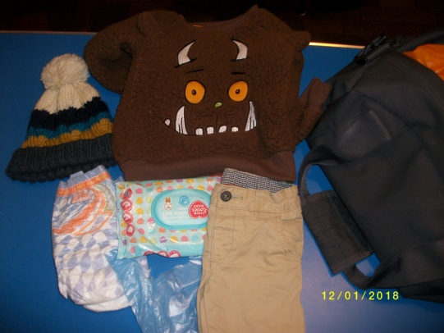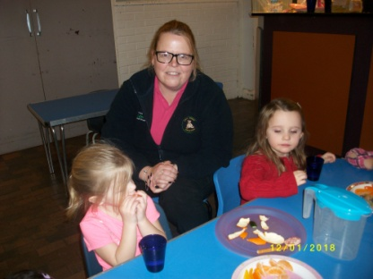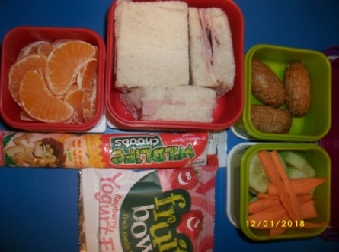

**RED BOOKS**

These are coming home soon and will have a message inside telling you what to do with them.

In their bag every child should have a change of clothes including socks, pants, trousers and a top. Don't forget to name them all! Plus, enough nappies or pull ups for a day if needed.

Please remember children need warm clothes in this cold weather, so that they can enjoy themselves outside.

**Welcome!**

We would like to welcome our newest member of staff Michelle Ruffles.

**PACKED LUNCHES**

Should include;

A sandwich, vegetables, fruit, yoghurt and a treat.

**Children's bags**

# **Dates for your DIARY**

**PE:**

Monday 22nd January

Friday 23rd February

Monday 12th March

T-shirt and shorts not needed this term.

**Show &Tell:**

Wednesday 7th February

Monday 26th February

Children should bring objects from home, labelled with their name.

**Big School Club:**

Wednesday 31st January

Tuesday 6th March

This activity will help your child get ready for the school environment. Your child does not need to bring anything for this session but you may like to talk to your child about their experiences.

**Term dates:**

Spring Half-term 12th - 16th February

Easter holiday 23rd March - 6th April

Parents Morning Monday 9th April (am)

Summer half-term 28th May - 4th June

Summer holiday starts Friday 20th July

**Keep updated**

Keep up-to-date by checking our facebook page and website:

emmergreenpreschool.org.uk

**Bad weather**

If the weather is really bad, please check the website for updates. We will send a text message ASAP to let you know of any closures or changes.

**BINGO NIGHT! SATURDAY 27th JANUARY**

7pm buy your books. 7:30pm eyes down!

Fish'n'chip supper £7.50 + BYO!  
PLEASE come and support the pre-school and help raise much needed funds. We also need prizes for the night, wine, chocolate, biscuits etc. Everyone welcome!