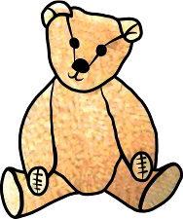

# **SOCIAL**

# **&**

# **FUNDRAISING EVENTS**

# These are currently in the planning process. We will keep you posted with dates for your diary!

# Over the past year our BINGO nights and the children’s sponsored Obstacle Courses have been most successful in raising funds.

Reg Charity

No.1087387

Emmer Green Pre-School

NEWS

LETTER

**0118 901 5506**

[www.emmergreenpreschool.org.uk](http://www.emmergreenpreschool.org.uk)  
[info@emmergreenpreschool.org.uk](mailto:info@emmergreenpreschool.org.uk)

SPRING 2019

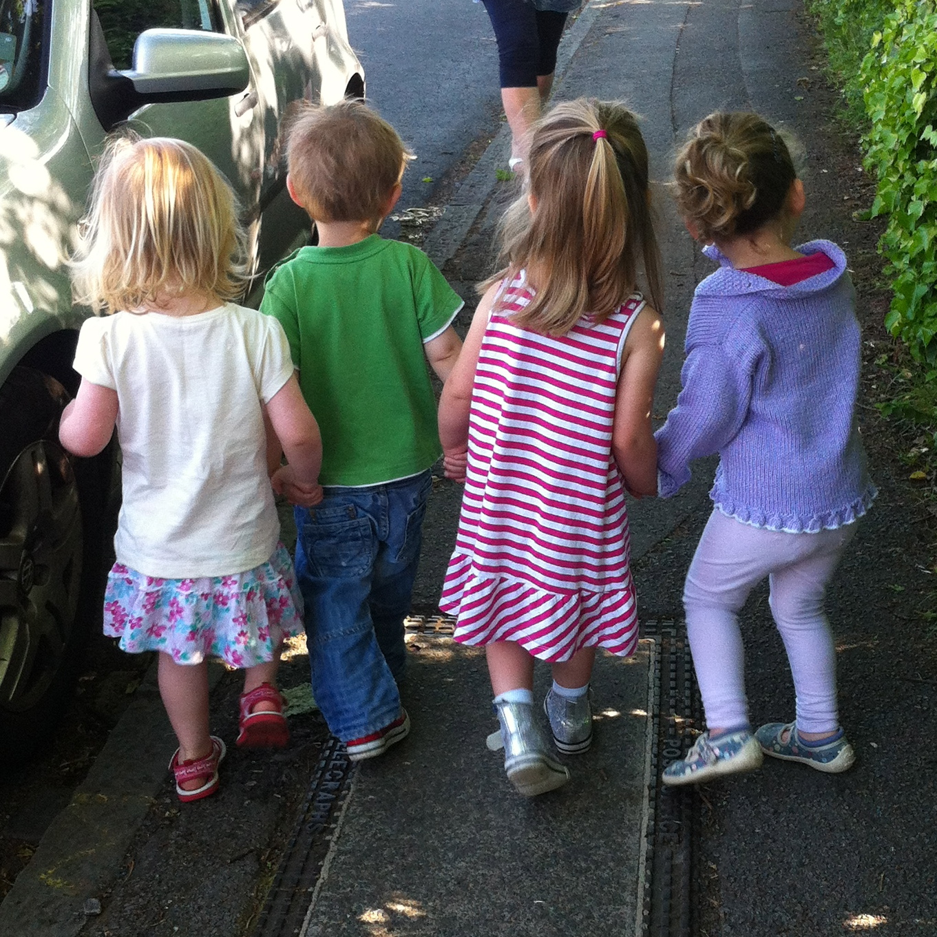

# **Dates for your DIARY**

**Show & Tell:**

Tuesday 29 January

Friday 1 March

Friday 29 March

Tuesday 7 May

Wednesday 5 June

Please encourage your child to bring something they would like to show everyone and talk about. Please name all Show & Tell items.

**PE:** *no PE kit required*

Monday 21 January

Tuesday 12 February

Friday 15 March

**Big School Club:**

Monday 21 January

Tuesday 12 February

Friday 15 March



# **Dates for your DIARY**

**Show & Tell:**

Tuesday 29 January

Friday 1 March

Friday 29 March

Tuesday 7 May

Wednesday 5 June

Please encourage your child to bring something they would like to show everyone and talk about. Please name all ‘Show   
& Tell’ items.

**PE:** *no PE kit required*

Monday 21 January

Tuesday 12 February

Friday 15 March

Tuesday 21 May

**Big School Club:**

Wednesday 6 February

Monday 29 April

Tuesday 11 June

This term promises more Pre-school learning and fun, please see ‘Dates for your DIARY’!   
Also see our ‘Social   
& Fundraising Events’ section to help us continue to raise important funds for new Pre-school equipment.

* Felt tip pens
* Glue Sticks
* Paper
* Card
* Right – handed children’s scissors

**THINGS WE NEED PLEASE**

IF YOU HAVE ANY SPARE AT HOME THEY WOULD BE REALLY USEFUL

**REMINDERS**

**CAR PARKING**

**Please remember** there is no parking at Pre–school. Please do not park in the doctors or residential home.

**ILLNESS**

**Please remember** that if your child is ill with colds, temperatures, ear infections, viruses etc. all they want is their Mummy or Daddy. Please let a member of staff know if you have given your child Calpol or other medicine before Pre-school.­





***Welcome back!***We hope you all enjoyed the Christmas break.  
Here’s a lovely photo from the fantastic Christmas party   
with Bertie slippers!

