NEWS

LETTER



**PRE-SCHOOL**

**REMINDERS**

Summer 2016

**Sickness/upset stomach –** Please keep your child out of pre-school for 48hrs after sickness and ensure they are fit and well before returning to pre-school as we are having issues with bugs circulating.

**If members of staff become ill this affects our adult-child ratio and means we will have to close the pre-school.**

Please remember…

**Mobile phones MUST NOT BE USED** when you are within the pre-school. This is both our policy and a safeguarding issue which **MUST** be taken very seriously.

**Cut fruit -** if lunch boxes contain small fruit and/or tomatoes, please ensure they are cut up into small, manageable pieces to reduce the risk of choking.

**Car parking and safety** - unfortunately there is no parking outside the children's centre for parents and there is now a traffic warden patrolling the area. Please ensure all children travel in an age/size appropriate car seat and we ask you not to leave any siblings in your car whilst collecting children from the pre-school.

**Late pick-up reminder –** as outlined in our Late Collection Policy, fees will be charged if children are persistently being collected late from pre-school.

5mins late: £5 10mins late: £10 10-15mins late: £15

**Outdoor play –** when the hot weather arrives, please bring named sun protection to pre-school for your child: hats and sun cream.

**Library books** - please return library books in the book bag once your child has finished with them. You will be given a new one to take home.

**We are looking forward to the Summer term and all that is planned for the children and parents to enjoy.**

This is a special term for a large number of children who will be preparing to go to school in September. We will be working with our local schools to create as many opportunities as possible for site visits to help with the children’s transition to their new schools.

**Schools are due to announce places on** **Monday 18 April** – please let us know which school you have been allocated so we can begin preparations for your child to visit their prospective school.

Please do take some time to read the newsletter which includes important reminders, dates for your calendar and information about upcoming events.

We wish you all a happy and successful term ahead. If you have any questions please do not hesitate to ask a member of staff for more information.

**News from Spring term**

**EASTER BONNET PARADE**

The children showed off their beautiful homemade bonnets when they took part in our annual Easter bonnet parade on Tuesday 22 March. Congratulations to competition winners Tommy Briggs, Ava Graham (not pictured) and Noah Baker who each won an Easter egg prize, donated by Budgens of Emmer Green. Coverage of the children in their bonnets appeared on getreading and in the Henley Standard.

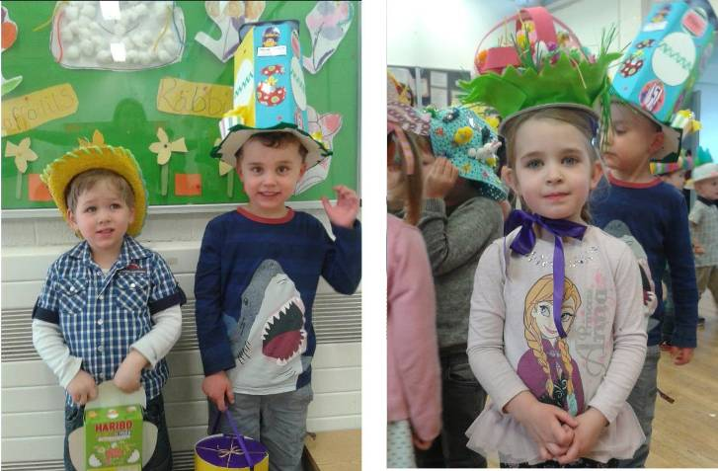

# SUMMER 2016

Emmer Green Pre-School

**0118 901 5506**

[www.emmergreenpreschool.org.uk](http://www.emmergreenpreschool.org.uk)  
[info@emmergreenpreschool.org.uk](mailto:info@emmergreenpreschool.org.uk)

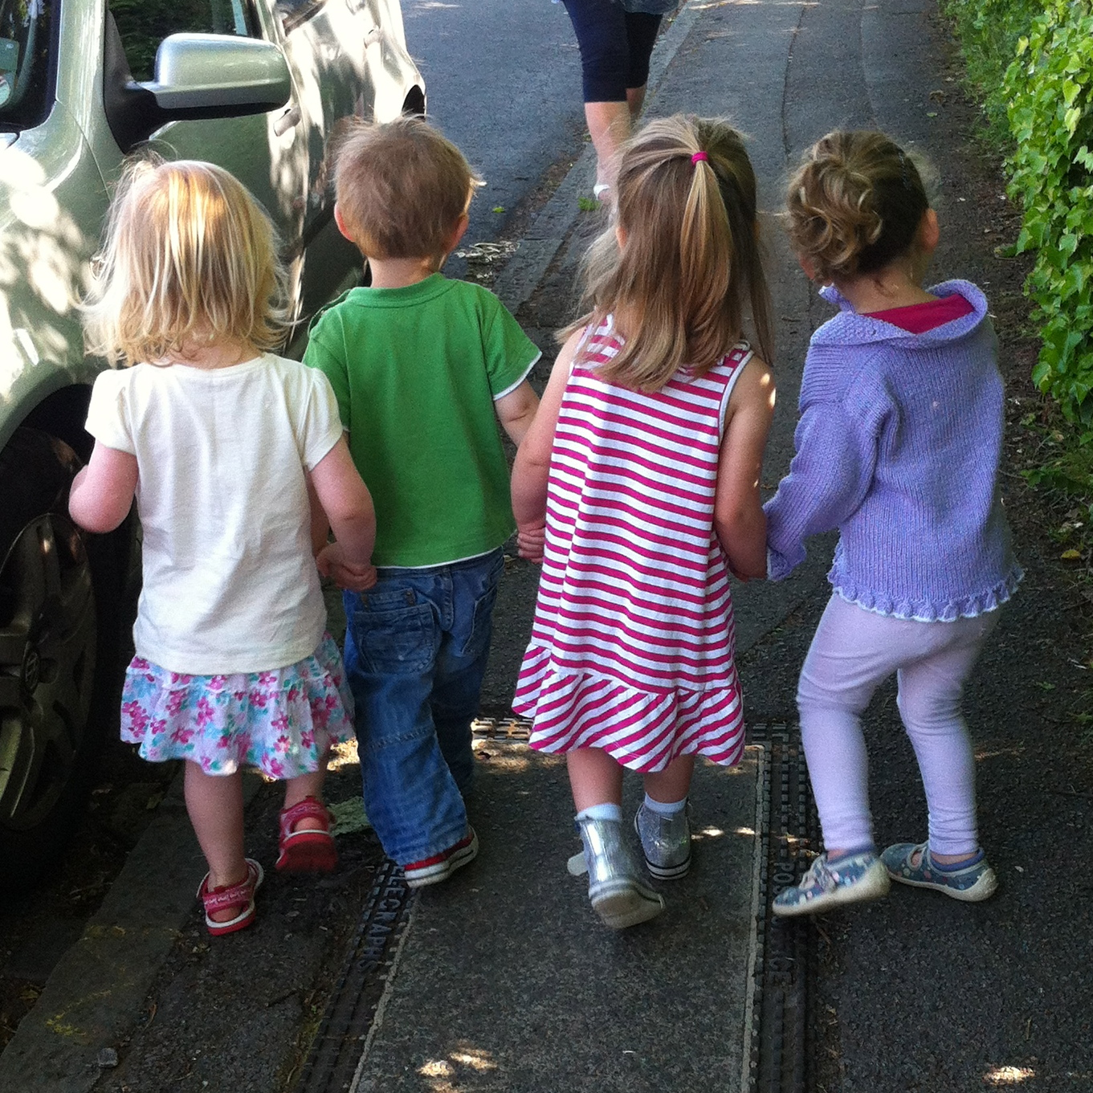

**News for Summer term**

**SCHOOL PLACES**

**– September 2016 intake**

You are due to be informed of your child’s school place on **Monday 18 April 2016.** Please let us know your child’s school as we can then work with the staff to facilitate school visits.

**MAY FAIR**

**- Fundraising Event**

- Saturday 21 May 2016, 12pm-3pm at Emmer Green Primary School, Grove Road.

We will have giant bouncy castles, 4x4 Jeeps for kids, Ferret Racing, Morris Dancing , lots of traditional fair games and a BBQ, Bar and Pimms Tent – it’s a great afternoon for the whole family so please put the date in your diary.

If you can spare 30mins on the day please put your name down to help on a stall etc – we’d like to have as much help as possible to make this a successful fundraiser for the pre-school.

**GROUP PHOTO**

- Friday 27 May

- AM & PM sessions

This is a great opportunity to have a photo to keep of your child with their pre-school friends.

**GRANDPARENTS’ WEEK**

- Monday 13 June-Friday 17 June

We will be asking you to invite grandparents into pre-school throughout this special week. If any grandparents have particular skills or hobbies that they’d like to share, such as gardening, cooking, music or simply coming in to read books – anything they think the children would enjoy – then please let us know. We’d love to have them join us.



Easyfundraising.org.uk is a great way to raise funds for our pre-school by simply doing your normal online shopping. A large number of well-known retailers (amazon.co.uk, John Lewis etc) donate to charities if you purchase after logging in via this site – you don’t pay any extra. It just takes 10 seconds to register and is as simple as that. We’d really appreciate if you could use this service – every penny counts!

**LABELLING BELONGINGS**

Please ensure you label your child’s belongings with big and bold names so staff can find bags, coats etc more easily.

**ITEMS NEEDED BY PRE-SCHOOL**

We are very much in need of the following items. If you have anything you think is suitable please speak with a member of staff:

* **Gardening things** – compost, grass seed, flower bulbs etc to plant
* Any **craft paper, cotton wool** etc
* **Outdoor toys**

**SNACKS AND HEALTHY EATING**

**Healthy eating -** please try to give your child healthy food in their lunch box, as the pre-school is keen to encourage healthy eating. Remember small fruit and tomatoes need to be cut to reduce the risk of choking.

Please make sure you pack an appropriate lunch. For example 1 sandwich, 1 yogurt, some cut up fruit or veg and a tasty treat.

**Allergies -** please be aware we do have children with serious allergies in the pre-school and so it is important that everyone is careful of items which contain nuts or sesame seeds. Be especially careful about items such as Tracker or cereal bars.

# **Dates for your DIARY**

**PE:**

**\*Please bring named shorts and t-shirt\***

Footwear not required

Tuesday 19 April

Friday 13 May

**Show &Tell:**

Please encourage your child to bring something they would like to show everyone and talk about for Show and Tell.

Monday 25 April

Wednesday 18 May

**Big School Club:**

All children attending preschool throughout the week are invited to attend events.

Wednesday 4 May

Monday 23 May

**May Fair**

Our annual fair will take place on Saturday 21 May from 12pm-3pm at Emmer Green Primary School’s playing fields.

It’s always a fun afternoon for all the family – we’d love to see you there and help raise important funds for the pre-school.

**Group Photo**

To take place AM and PM.

Friday 27 May

**Sports Day**

More info nearer the date.

Date TBC

**Teddy Bear’s Picnic**

More info nearer the date.

Wednesday 20 July