**PRE-SCHOOL**

**REMINDERS**

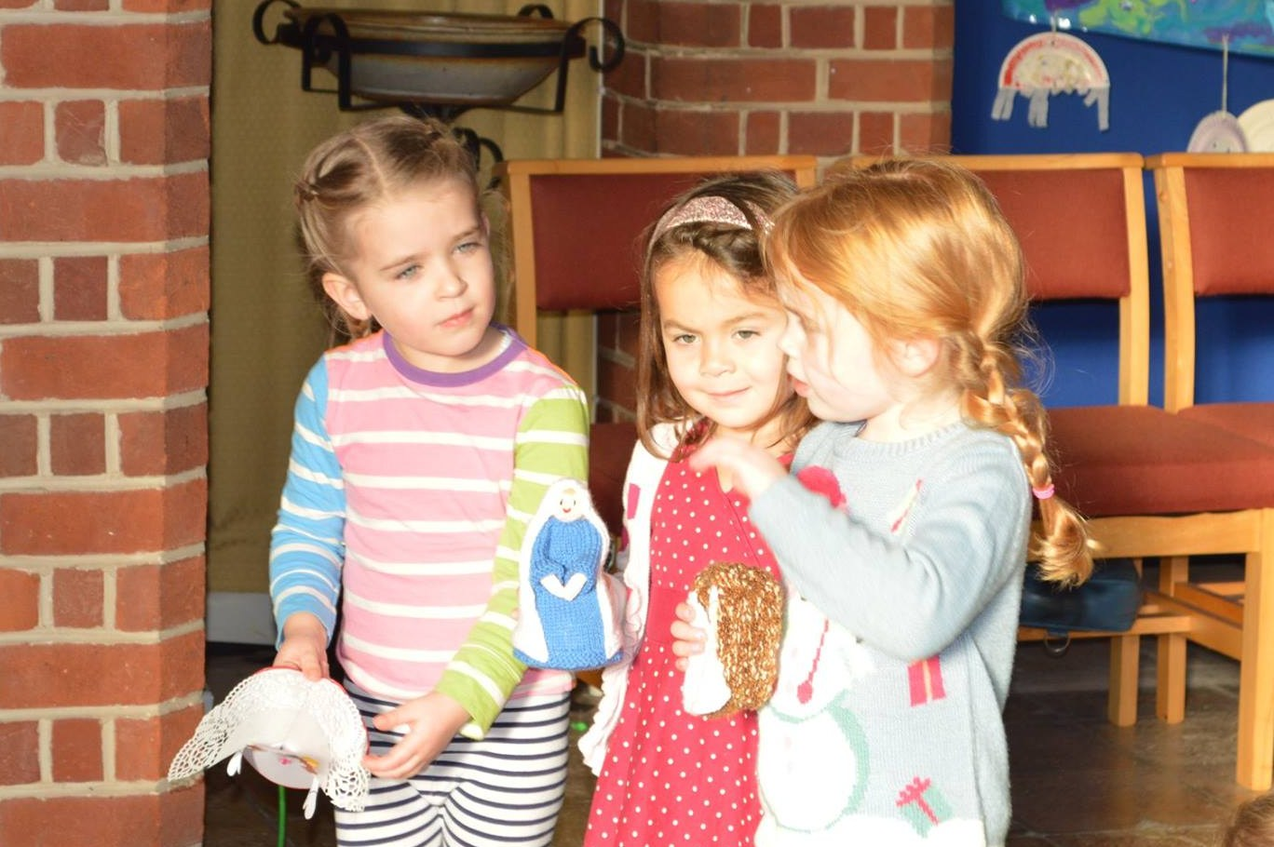

**0118 901 5506**

[www.emmergreenpreschool.org.uk](http://www.emmergreenpreschool.org.uk)  
[info@emmergreenpreschool.org.uk](mailto:info@emmergreenpreschool.org.uk)

**Emmer Green Pre-School hopes everyone enjoyed the holiday festivities and wishes all families a very Happy New Year!**

We would like to congratulate our assistant Hannah Longstaff on her engagement to her partner, Andy and wish them much happiness for their future together!

We are looking forward to the Spring term and all that is planned for the children and parents to enjoy. Please do take some time to read the newsletter which includes important reminders, dates for your calendar and information about upcoming events.

We wish you all a happy and successful term ahead. If you have any questions please do not hesitate to ask a member of staff for more information.

PRESCH

[Emmer Green Pre-School](http://emmergreenpreschool.org.uk/)

# SPRING 2016



Please remember…….

**Outdoor play - cold weather clothes.** Please bring hats, gloves and wellies for each session ensuring all items of clothing are named.

**Carparking and safety.** Unfortunately there is no parking outside the children's centre for parents and there is now a traffic warden patrolling the area. Please ensure all children travel in an age/size appropriate car seat and we ask you not to leave any siblings in your car whilst collecting children from the pre-school.

**Library books.** Please return library books in the book bag once your child has finished with them. You will be given a new one to take home.

**If lunch boxes** contain fruit and or tomatoes, please ensure they are cut up into small, manageable pieces to reduce the risk of choking.

**Mobile phones must not be used** when coming into pre-school and when dropping off and picking up your child. This is to ensure the safety of all children attending pre-school.

Spring 2016

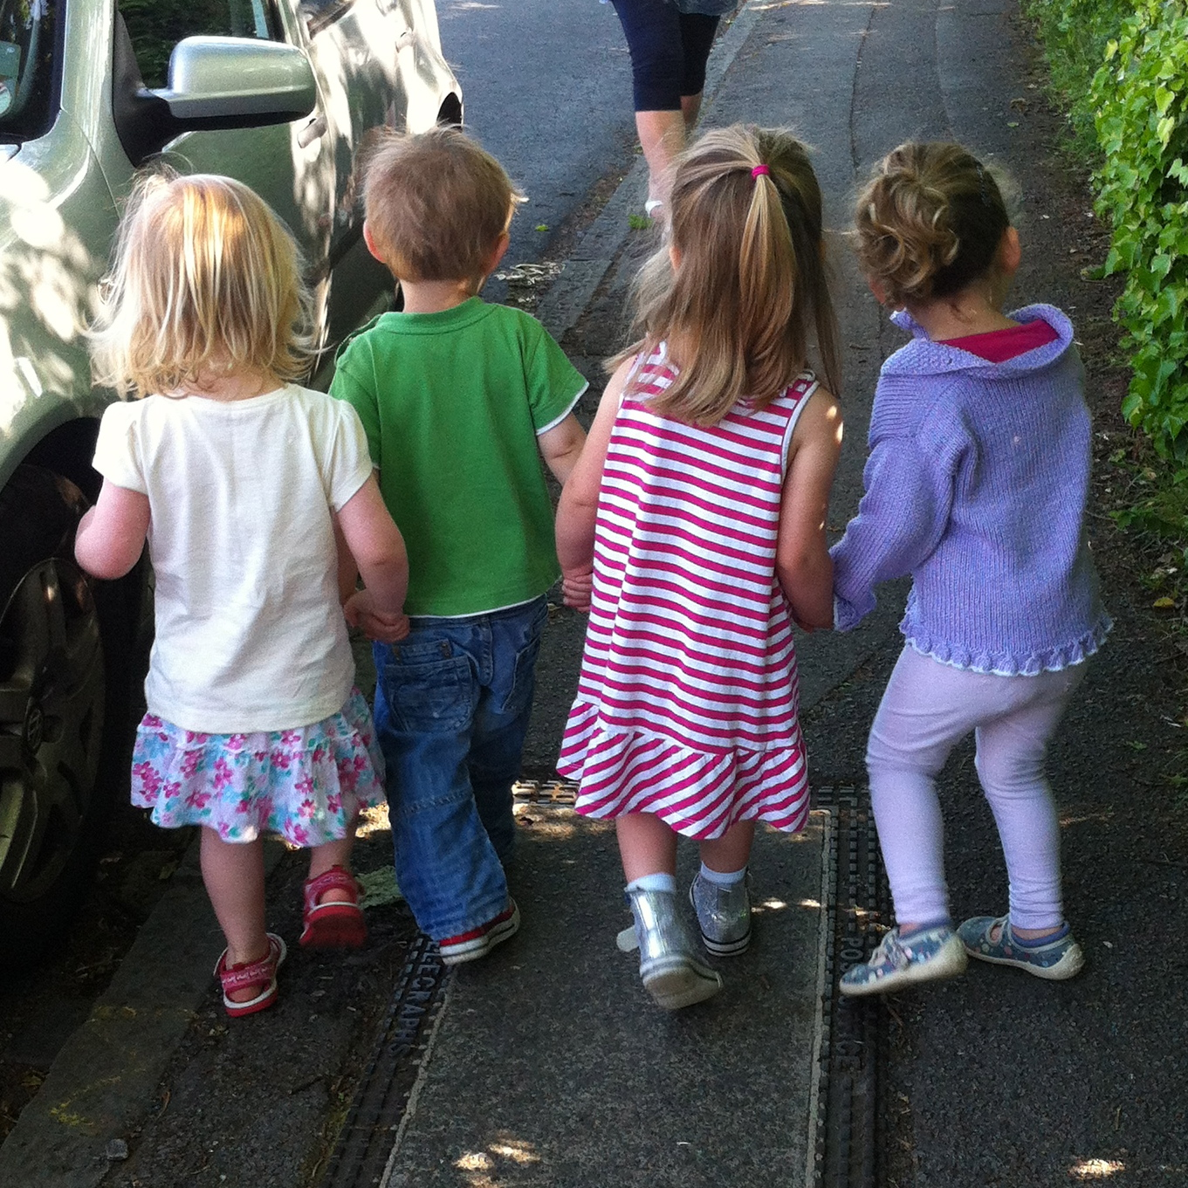

**Christmas Songs at St Luke's Care Home**

Wednesday 2nd December we walked to St Luke's Care Home in Marshland Square, armed with mince pies and our best singing voices, to meet the residents and bring some festive cheer in the run-up to Christmas.  The children sang a mix of traditional and contemporary Christmas songs after they’d had fun colouring in Christmas pictures provided by St Luke’s staff.  Four year old Grace Toomey, said: “I really liked singing the Christmas songs with my friends and the older people.  My favourite song is ‘When Santa Got Stuck Up the Chimney’.”

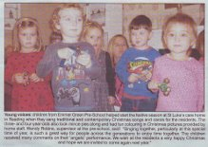

Pam Hobbes, activities co-ordinator at St Luke’s Care Home, said: “The children were absolutely fantastic and our residents really enjoyed meeting them.  What better way to spread the festive cheer than with the wonderful sound of the youngsters performing carols around our Christmas tree.”

This is the second time we have visited the care home, this year appearing in The Henley Standard and The Reading Chronicle.

**Christmas Raffle**

Thank you to everyone who took part in our Christmas Raffle. We achieved a fantastic fundraising total of £612 from the raffle, our first ever silent auction plus teas & mince pies after the church service on Wednesday 9th December. Every penny will be put towards buying much-needed ICT equipment for the children to use, helping us to update and improve the play setting for our children. A massive thank you to our committee for all their hard work arranging the raffle and auction and to all the local businesses that kindly donated prizes. And a special thank you to the lovely Lyndsey for offering an evening of babysitting as a silent auction lot which went for an impressive £30!!

**Fundraising Event - RACE NIGHT**

**When**: Saturday 16 April 2016, doors open at 7.30pm, first race at 8.00pm.

**Where**: Emmer Green Primary School, Grove Road.

Following the success of last year's race night, this is going to be another noisy and fun night where you can place your bets and race a wooden horse along the 25ft track.  Don’t worry if you haven’t been to a race night before, we’ll explain how it works on the night.

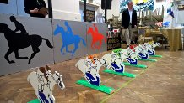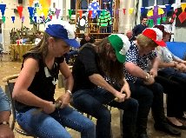

Tickets are £10 and include dinner.  This is a great way to have a good night out and support the pre-school at the same time so please invite family and friends and arrange babysitters if you can.

# **Dates for your DIARY**

**PE sessions and**

**Show &Tell**

PE sessions and Show & Tell will take place on the same day on the following dates:

Monday 18 and Tuesday 26 January. Wednesday 3, Friday 12 and Friday 26 February. Wednesday 2 March.

Please encourage your child to bring something they would like to show everyone and talk about for Show and Tell. No need for a change of clothes for PE sessions until after half term.

**Big School Dates**

All children attending preschool throughout the week are invited to attend events on:

Friday 22 January. Monday 1 and Friday 29 February.

Tuesday 8 and Friday 18 March. Details to follow.

**Easter Service**

The Easter Service will take place on Tuesday 22 March at 1pm at St Barnabas Church. A letter will be sent out with further details.

**Open Morning**

This is an opportunity for you to talk to your child’s key worker about his/her progress. It will take place on the morning of Monday 11 April. There will be no afternoon session on this day.

**Race Night**

(See newsletter for more details.)

Saturday 16 April at 7.30pm at Emmer Green Primary School.

**WINTER WEATHER PREPARATION**

It is that time of year again when we need to inform you of procedure in the event of significant snowfall.

**CLOSURE OF PRESCHOOL:**

Parent/carers will be informed via text, email, the website and local radio stations.

**SNOWFALL DURING THE DAY:**

Please do stay tuned to weather forecasts. We would notify you by email, text or phone call if we felt the weather was bad enough to ask you to collect your child early.

**THINGS NEEDED FOR PRE-SCHOOL**

The computer that the children use is in need of a new screen. If anyone has an old one or thinks they can help, please speak with a member of staff.

**SNACKS AND HEALTHY EATING**

**Healthy Eating.** Please try to give your child healthy food in their lunch box, as the pre-school is keen to encourage healthy eating. Remember small fruit and tomatoes need to be cut to reduce the risk of choking.

Please make sure you pack an appropriate lunch. For example 1 sandwich, 1 yogurt, some cut up fruit or veg and a tasty treat.

**Allergies.** Please be aware we do have children with serious allergies in the pre-school and so it is important that everyone is careful of items which contain nuts or sesame seeds. Be especially careful about items such as Tracker or cereal bars.



**Pre-School Winter Weather Procedures**