PRESCH

[Emmer Green Pre-School](http://emmergreenpreschool.org.uk/)

# AUTUMN 2015

**Emmer Green Pre-school welcome all the new families that have joined us.**

We know that this is a new and exciting time for you and your children. We want to ensure that this term goes as smoothly as possible. If you have any questions please come and ask one of the members of the team.

There a number of things to remember and although there seem to be lots of details, these will soon become second nature.

You may be interested in our most recent Ofsted report. If you are you can read the full details at reports.**ofsted**.gov.uk/provider/files/2499476/urn/116826.pdf

We rely on parent support and participation in our sessions. Helping at the session gives you a great chance to see your child in the pre-school environment and for you to help the Pre-school. Look out for the Parent helper rota which will be displayed on the notice board. We look forward to seeing you at pre-school.



**0118 901 5506**

[www.emmergreenpreschool.org.uk](http://www.emmergreenpreschool.org.uk)  
[info@emmergreenpreschool.org.uk](mailto:info@emmergreenpreschool.org.uk)

Please remember…….

**Outdoor play - cold weather clothes.** Please bring hats, gloves and wellies for each session ensuring all items of clothing are named.

**Carparking and safety.** Unfortunately there is no parking outside the children's centre for parents and there is now a traffic warden patrolling the area. Please ensure all children travel in an age/size appropriate car seat and we ask you not to leave any siblings in your car whilst collecting children from the pre-school.

**Library books.** Please return library books in the book bag once your child has finished with them. You will be given a new one to take home.

**If lunch boxes** contain fruit and or tomatoes, please ensure they are cut up into small, manageable pieces to reduce the risk of choking.

**Mobile phones must not be used** when coming into pre-school and when dropping off and picking up your child. This is to ensure the safety of all children attending pre-school.

autumn

2015

**PRE-SCHOOL**

**REMINDERS**

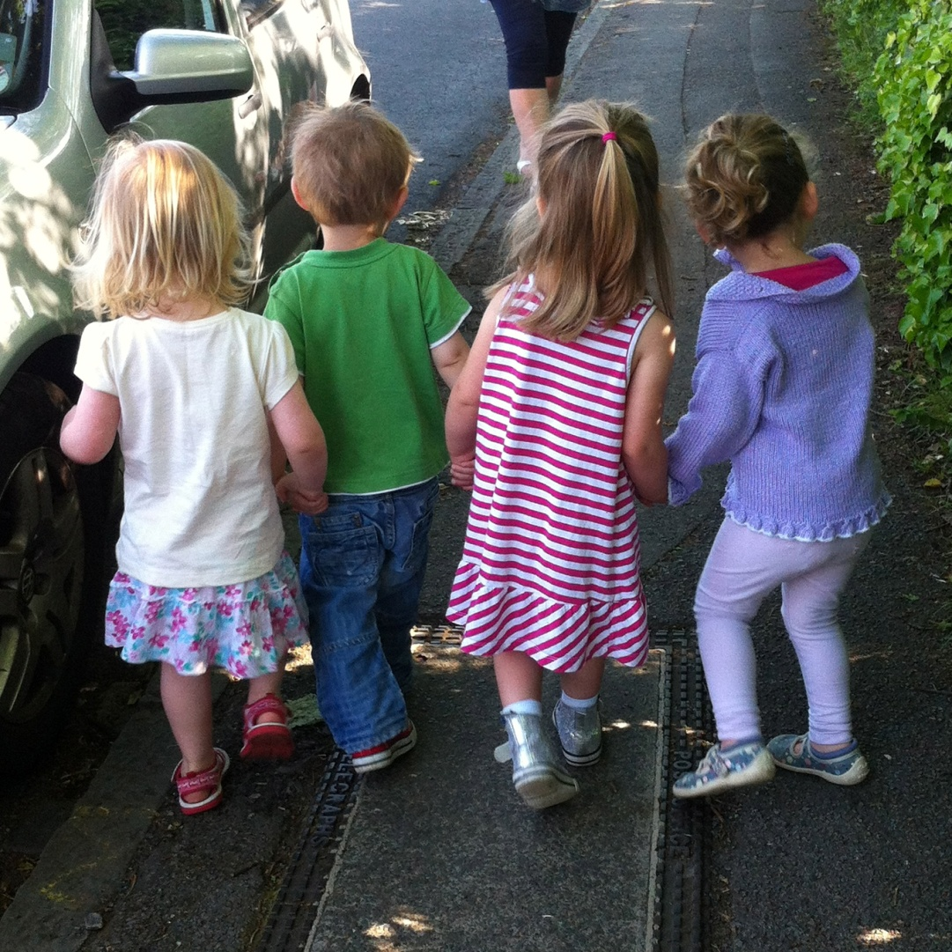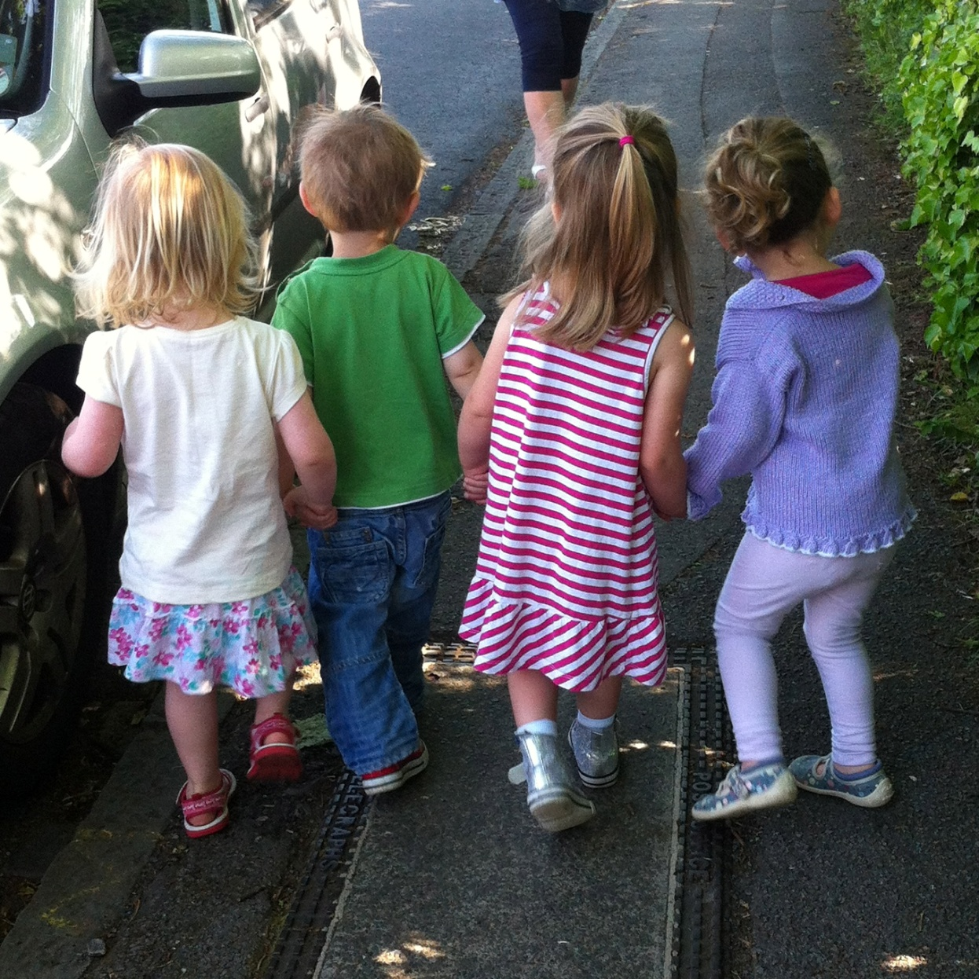

# Dates for your **DIARY**

**PE DATES/SHOW & TELL**

Tuesday 17 November and Tuesday 1st December

**BIG SCHOOL DATES**

Monday 9 November PM and Wednesday 9 December AM

**DRAMA SESSION WITH NICOLE LOVELOCK**

Nicole is a parent and drama teacher who will be coming in to do a drama session in the afternoon on Tuesday 24 November

**CHRISTMAS CHURCH SERVICE**

This will take place on Wednesday 9 December at St Barnabas Church at........It will be followed by tea, coffee and cake and the drawing of the raffle.

**CAROL SINGING TO OLDER ADULTS**

This will happen at St Lukes on Wednesday 2 December at 10.30am.

**LAST DAY OF TERM** is on Friday 11 December and is a morning session only from 9-11.30am. There will be a Christmas party for ALL children.

**Snacks and Eating**

**Healthy Eating.** Please try to give your child healthy food in their lunch box, as the pre-school is keen to encourage healthy eating. Remember small fruit and tomatoes need to be cut to reduce the risk of choking.

Please make sure you pack an appropriate lunch. For example 1 sandwich, 1 yogurt, some cut up fruit or veg and a tasty treat.

**Allergies**. please be aware we do have children with serious allergies in the pre-school and so it is important that everyone is careful of items that contain nuts or sesame seeds. Be especially careful about items such as Tracker or cereal bars.

**VOLUNTEERS TO HELP WITH CAROL SINGING TO OLDER ADULTS**

The children will be going to St Lukes to sing Christmas carols to Older Adults on Wednesday 2 December and we would be grateful for any parents able to help us walk the children to St Lukes and hold their hands. The times are......

**CHRISTMAS RAFFLE PRIZES**

We will be holding a Christmas raffle and would be grateful if you could donate any prizes for it. Raffle tickets will be given to you to sell. The raffle will be drawn on Wednesday 9 December after the Christmas Church Service.

**LETTER TO SANTA**

We will be helping the children to write a letter to Santa and will need a stamped addressed envelope please. We will be walking to the post office to post them.

**TRIPLE P POSITIVE PARENTING PROGRAMME**

This is a free training course for parents with children displaying potentially challenging behaviour. The dates are Friday 8 January 2016 at Katesgrove from 12.30-2.30pm and Thursday 14 January at Emmer Green Children's Centre from 12.30-2.30pm.

**THINGS NEEDED**

**OUR WEBSITE** [www.emmergreenpreschool.org.uk](http://www.emmergreenpreschool.org.uk)

Our website is kept up to date with events and information. Some Pre-school forms are available on the website in the ‘Committee and Parents’ section, so if you need forms relating to administering medicine at pre-school, notification of holidays or of incidents at home these forms are now all available to print from the website.

Please remember to check our website regularly. In the event of bad weather or other situations closing the pre-school, updates will be available for you there.

We also have a Facebook page where updates will also be posted. Please remember to ‘LIKE’ and ‘SHARE’ the page if you are a Facebook user.